### Semester One Examination 2019

### Question/Answer booklet

# MATHEMATICS

**UNIT Methods 1 & 2**

## Section Two:

## Calculator-assumed

**Name:**

**Teacher’s Name:**

## Time allowed for this section

Reading time before commencing work: ten minutes

Working time: one hundred minutes

## Materials required/recommended for this section

***To be provided by the supervisor***

This Question/Answer booklet

Formula sheet (retained from Section One)

***To be provided by the candidate***

Standard items: pens (blue/black preferred), pencils (including coloured), sharpener, correction fluid/tape, eraser, ruler, highlighters

Special items: drawing instruments, templates, notes on two unfolded sheets of A4 paper, and up to three calculators approved for use in this examination

## Important note to candidates

No other items may be taken into the examination room. It is **your** responsibility to ensure that you do not have any unauthorised material. If you have any unauthorised material with you, hand it to the supervisor **before** reading any further.

| **Question** | **Marks** | **Question** | **Marks** |
| --- | --- | --- | --- |
| **10** |  | **18** |  |
| **11** |  | **19** |  |
| **12** |  | **20** |  |
| **13** |  | **21** |  |
| **14** |  | **22** |  |
| **15** |  | **23** |  |
| **16** |  | **Total** | **/92** |
| **17** |  |  |  |

**Structure of this paper**

| Section | Number of questions available | Number of questions to be answered | Working time (minutes) | Marks available | Percentage of examination |
| --- | --- | --- | --- | --- | --- |
| Section One:  Calculator-free | 9 | 9 | 50 | 52 | 36 |
| Section Two:  Calculator-assumed | 14 | 14 | 100 | **92** | 64 |
|  |  |  |  | **Total** | 100 |

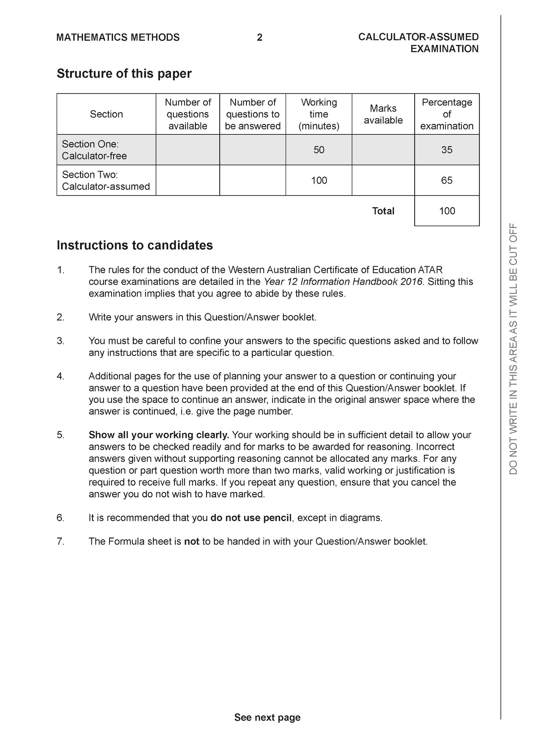

**Section Two: Calculator-assumed (92 Marks)**

This section has **14** questions. Answer **all** questions. Write your answers in the spaces provided.

Spare pages are included at the end of this booklet. They can be used for planning your responses and/or as additional space if required to continue an answer.

● Planning: If you use the spare pages for planning, indicate this clearly at the top of the page.

● Continuing an answer: If you need to use the space to continue an answer, indicate in the original answer space where the answer is continued, i.e. give the page number. Fill in the number of the question that you are continuing to answer at the top of the page.

Working time: 100 minutes.

**Question 10 (8 marks)**

A circle has a diameter from (2,6) to (10,-9). (5 marks)

(a) Find its centre and exact radius, hence state the equation of this circle.

(b) Determine the centre and the radius of the circle with the equation

.

(3 marks)

**Question 11 (8 marks)**

(a) The point *Q* has coordinates (, 7) and belongs to the function .

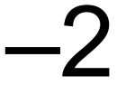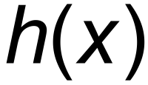

Obtain the new coordinates of *Q* after the following transformations.

(i) (2 marks)

(ii) (2 marks)

(b) The graph of *y* = *f* (*x*) is drawn below.

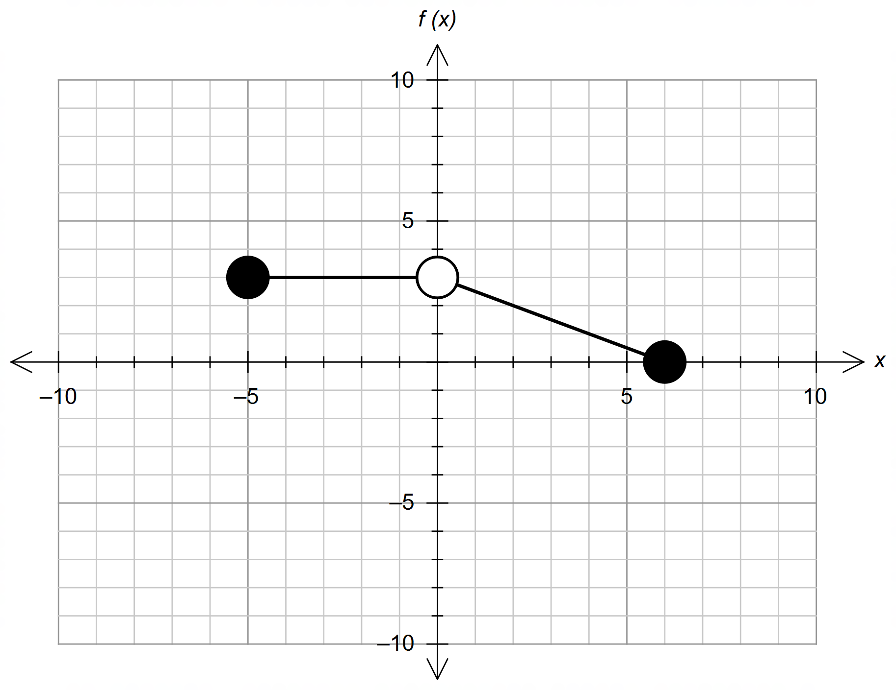

On the same axes, sketch the graphs of the following functions. Label each one clearly.

(i) (2 marks)

(ii) A vertical dilation by a factor of 3 and then a horizontal reflection is applied to (2 marks)

**Question 12 (8 marks)**

An open box is constructed by cutting out square corners, with sides *x* cm, from a sheet of cardboard 100 cm by 70 cm as shown below and folding along the dotted line.

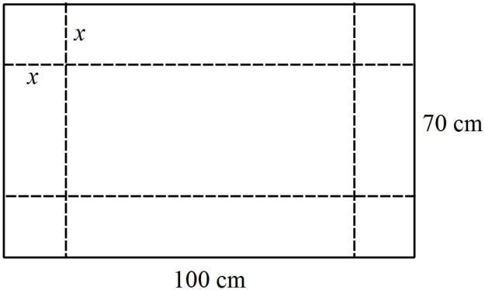

(a) Find an expression for *V* (cm3), the volume of the box, in terms of *x.*  (2 marks)

(b) Sketch the graph of *V* against *x* without any restriction on *x.*

(Do not find coordinates of turning points.) (2 marks)

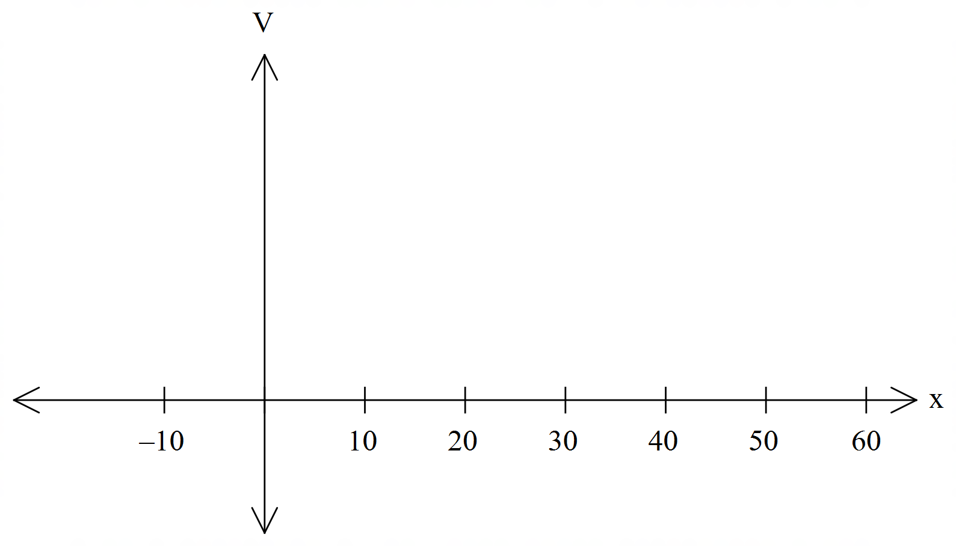

(c) Sketch the graph of *V* against *x* with the restriction on *x.*

(Do not find coordinates of turning points.) (2 marks)



(d)For what value(s) of *x* is *V* = 6664? Give your answer(s) to 1 decimal. (2 marks)

**Question 13 (6 marks)**

The square target shown has sides of length 2 metres. Inside the square are a grey circle of radius 1 metre, and a black circle of radius 0.6 metres. Suppose that a dart thrown at the target is equally likely to hit any part of the target.

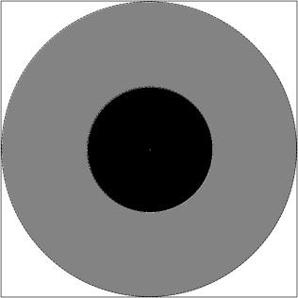

(a) Calculatethe probability that the dart will hit the grey region. (2 marks)

(b) Calculate the probability that the dart will hit the white region. (2 marks)

(c) Suppose that 10 points are awarded if the dart hits the grey region, five points if the dart hits the black region and zero points if the dart hits the white region. If two darts are thrown, state the probability that the total score is 10 points. (2 marks)

**Question 14 (6 marks)**

For the purpose of choosing a team for a quiz, a class is split into three groups. Group A contains 3 boys and 2 girls. Group B contains 1 boy and 3 girls, and Group C contains 2 boys and 2 girls. An unbiased die is thrown, and if a 1, 2 or 3 appears, a person will be selected at random from Group A. If a 4 or 5 appears, a person will be selected at random from Group B. If a 6 appears, a person will be selected at random from Group C.

(a) Find the probability that the first person is chosen from Group A. (1 mark)

(b) Calculate the probability that a boy from Group B will be chosen when the first choice is made. (2 marks)

(c) Calculate the probability that a boy will be chosen when the first choice is made.

(3 marks)

**Question 15 (6 marks)**

The figure below shows the parabolic arch under a railway bridge.

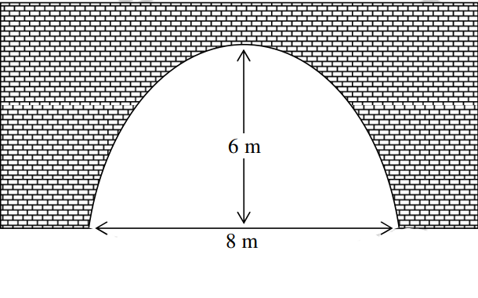

The width of the arch at its lowest level is 8 metres and the highest point of the arch is 6 metres from the ground.

(a) Given that the coordinate of the maximum height of the arch is (0,6). (3 marks)

Write a polynomial equation that models the arc under the bridge.

(b) Determine showing a clear algebraic method whether a truck with a width of 6 metres and a height of 2 metres can pass through this parabolic arch. (2 marks)

(c) What is the minimum clearance between the top of the truck and the arc? (1 marks)

**Question 16 (7 marks)**

Tessa owns an expensive riverside property that overlooks a vacant block and a river. The diagram below shows a cross-section of the location of the property.

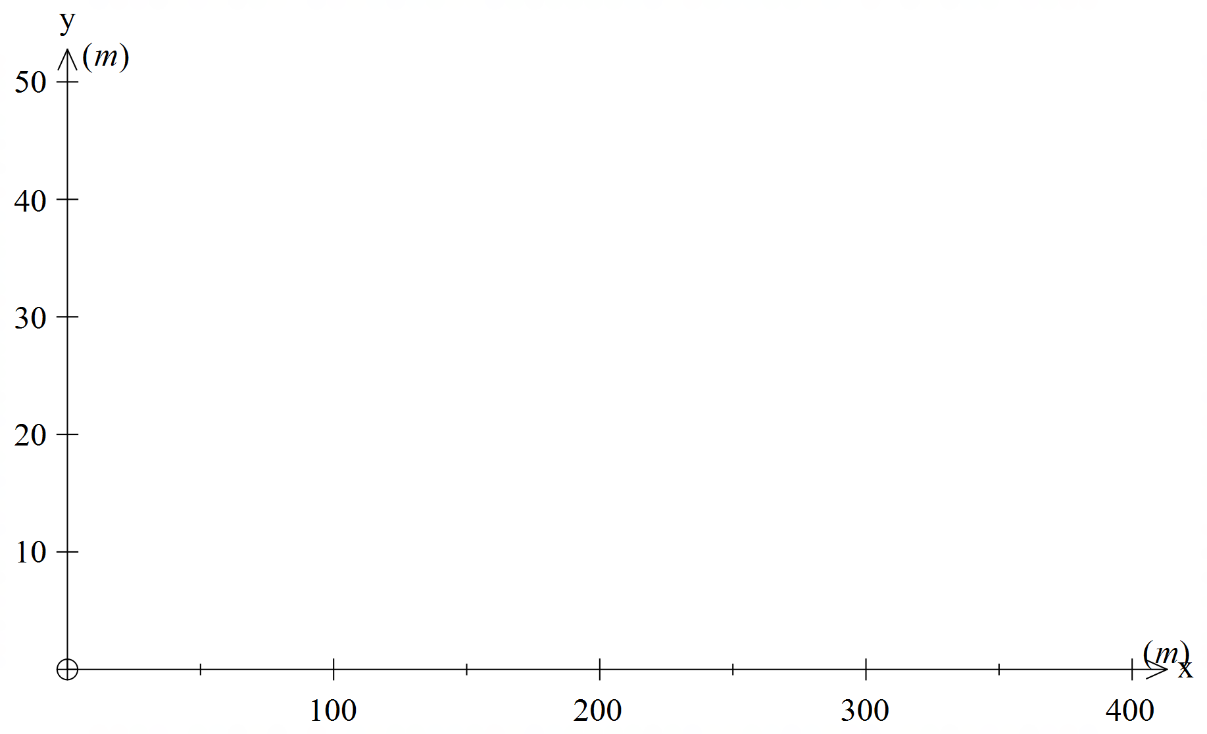



From Tessa’s patio at (0,30) she has a clear view of both the near and far banks of the river with coordinates (150,0) and (350,0) respectively.

(a) Find the equation of the line of sight from the patio to the Near bank of the river. (2 marks)

(b) A tree is planted at (50,0) and grows at a rate of 1 meter per year. If this tree grows to a maximum height of 30 meters, how long before the tree obstructs the view of the Near bank? (2 marks)

(c) A house is built on the vacant block with the highest point at (100,20). What would be the nearest point on the river that would be unobstructed by the roof? (3 marks)

**Question 17 (8 marks)**

The following teachers are involved in at least one of the following after school Maths competitions: Have Sum Fun (H), IM2C (I) or APSMO (A).

*Ms Ensly, Ms Rimando, Mr Strain, Mr Gannon, Mrs Thomas, Mr McClelland, Ms Shah,*

*Ms Reynolds and Mr Young*

***Use the Venn diagram opposite to assist you in setting up your solution.***

The following information about the teachers is known:

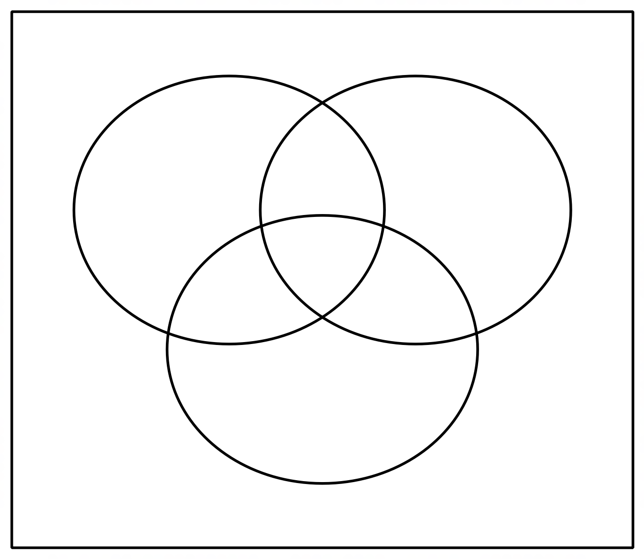

{Ms Reynolds, Ms Ensly} H

H I = {Ms Rimando, Mrs Thomas, Ms Shah}

H A = Ms Rimando, Mrs Thomas

= {Mr Strain}

A = {Ms Rimando, Mrs Thomas, Mr Young, Mr Strain, }

Determine:

1. I

(2 marks)

1. (2 marks)
2. (2 marks)
3. (2 marks)

**Question 18**  **(6 marks)**

The probabilities of two events, A and B, are such that P(A) = 0.35 and P(B) = 0.4.

Determine;

1. The minimum value of (2 marks)
2. By considering your answer to Part (a), what can you say about events A and B, when is a minimum.

(1 mark)

1. (1 mark)
2. The maximum value of (1 mark)
3. By considering your answer to Part (d), what can you say about the events of A and B when is a maximum? (1 mark)

**Question 19 (8 marks)**

Michael and Emma went to Mont Albert in the French Alps for a white winter Christmas.

As part of their holiday celebrations, they had booked a sleigh ride for Christmas Day.

However, sleigh rides can only take place when there is enough snow on the ground.

Previous winter snow fall readings show that 85% of the time, there is enough snow on the ground on Christmas Day. If there is snow on the ground, there is a 95% chance that sleighing will go ahead. If there isn’t enough snow on the ground, then there is an 70% that an alternate activity of a snowman building competition is organised.

(a) Complete a tree diagram to represent this situation. (3 marks)

(b) Calculate the probability that on Christmas Day Michael and Emma:

1. Go for a sleigh ride: (1 mark)
2. Have no activity planned for that day: (2 marks)
3. Experience enough snow on the ground, given that they have no activity planned for that day. (2 marks)

**Question 20 (5 Marks)**

Consider the cubic function has roots at ( and (

(a) Fully expand (2 marks)

(b)State the coordinate of the y intercept, in terms of a and b (1 mark)

(c) Given , find the value of a and b (2 marks)

**Question 21 (8 marks)**

The graph of the function is defined by is shown below.

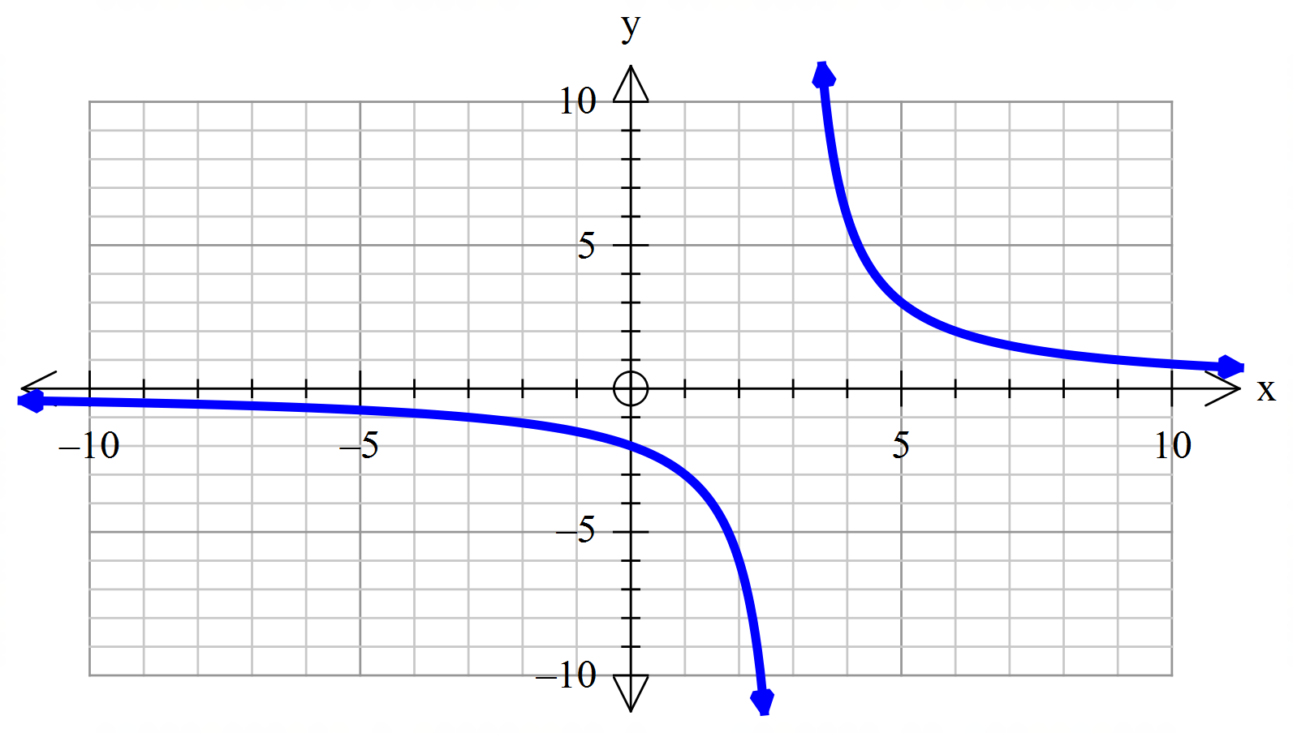

(a) Determine the values of and . (2 marks)

(b) State the domain and range of . (2 marks)

(c) Determine the equations of the asymptotes of the graph of . (2 marks)

(d) Describe the transformation required on the graph of to obtain the graph of

(i) . (1 mark)

(ii) . (1 mark)

**Question 22 (3 marks)**

One of the solutions to the equation is .

Determine the value of and all other solutions.

**Question 23 (5 marks)**

Consider the quadratic equation

(a) Find the discriminant.

(b) Find the values of for which there are 2 solutions.

(c) Find the values of for which there are no solutions.

(d) Find the values of for which there is 1 solution.

**End of questions**

**Additional working space**

**Additional working space**